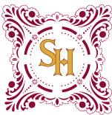

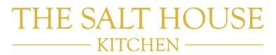

Christmas fayre 2016

*All of our food is cooked fresh to order so your patience would be greatly appreciated during busier times.*

**Starters**

Smooth Duck Mousse, Spiced Mulled Wine Chutney & Granary Fingers

Tiger Prawn & Smoked Salmon Salad, Lemon & Chive dressing

Roasted Red Pepper & Basil Soup, Garlic & Pesto Crostini (v)

Smoked Chicken, Pancetta & Stilton Tart with an Orange & Cranberry Drizzle

**Mains**

Roast Cumbrian Turkey Breast served with Pigs in Blankets, Chestnut, Cranberry & Herb Stuffing in a Rich Gravy

Beef & Double Maxim Casserole with Stilton & Thyme Dumpling

Fillet of Salmon with a Watercress, Lemon & wholegrain Mustard Sauce

Chicken Breast stuffed with Black Pudding, Walnuts & Tarragon wrapped in Pancetta &served with a Whiskey Jus

*All of the above dishes are served with Duck Fat Roasties, Mashed Potato & Seasonal Veg*

Sweet Potato & Butternut Squash Risotto topped with a Sweet Potato Crisp & Wild Rocket (v)





Christmas fayre 2016

*All of our food is prepared fresh to order so your patience would be greatly appreciated during busier times. Thank You.*

**Desserts**

Northumberland Christmas Pudding with Brandy Sauce

Strawberry & Amaretto Trifle

Sticky Marmalade Pudding with Double Ginger Ice Cream

Baileys & Chocolate Cheesecake with Chantilly Cream

Local Weardale Cheeseboard, Artisan Crackers, Grapes & Celery (£1.50 supplement)

**Two Courses £18 Three Courses £22.50**